



**A PRACTICE ABSTRACT ON UPSCALING PPT THROUGH SCHOOLS IN KENYA**

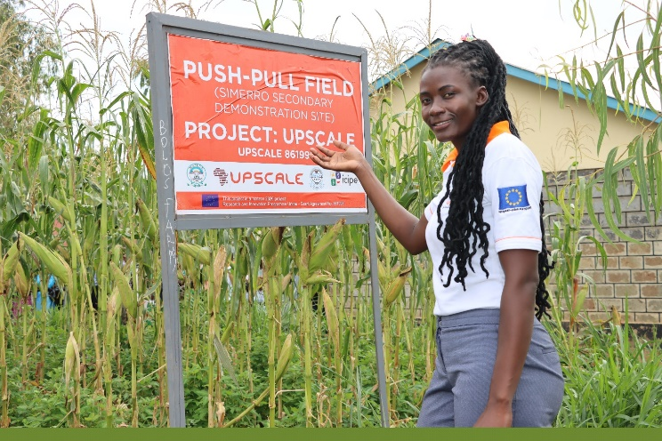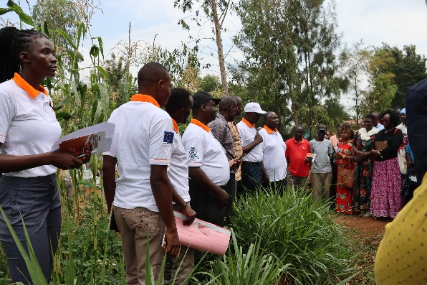

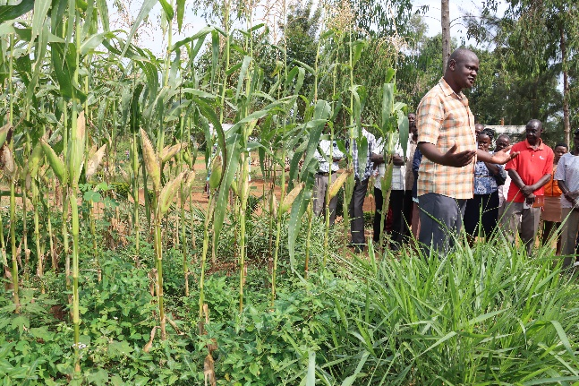 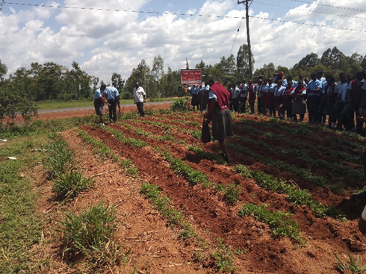

Photos: The Maseno University UPSCALE team and farmers at ST. Albert Simerro Secondary School on 28th of July 2023

Maseno University's UPSCALE project team is focused on enhancing awareness of push-pull technology (PPT) across the region. One of the strategies that has been implemented is establishing PPT plots in schools and organizing school field days to engage students, parents, teachers, and local farmers. The main objectives of these events are to educate participants about PPT farming, teach them how to establish PPT plots, highlight the benefits of PPT farming, and distribute PPT learning materials. This initiative has been successfully carried out in two schools so far.

By: Denis Kimoso Mulupi, Dr. Fredrick Aila, Dr.Benjamin Ombok, Prof. Geoge Odhiambo

Maseno University