



**A PRACTICE ABSTRACT ON RWANDAN UPSCALE MULTIACTOR COMMUNITY (MAC) OF PRACTICE SUSTAINABILITY**

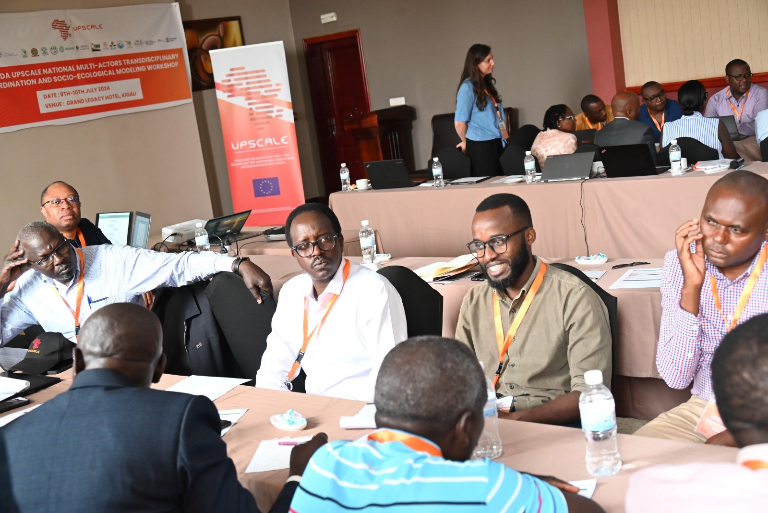

The Rwanda MAC meeting on the 7th- 9th of July 2024

The Rwandan multiactor community (MAC) of practice in the UPSCALE Project is focused on enhancing awareness and fostering stakeholder engagement to support the adoption and adaptation of push-pull technology (PPT). The stakeholder analysis of MAC members indicates a high level of interest, impact, and benefits associated with PPT, with low potential conflicts. The MACs main challenges are high initial cost for PPT establishment, climate change, shortage of nurseries, a limited number of seed merchants for PPT inputs and possibilities on rotating PPT with other crops, low accessibility, and poor tracking of PPT inputs, lack of regulations on the PPT inputs market, lack of market for the Desmodium and Bracharia fodder, and small sizes of land. There is a need for local production of seeds under the supervision of a quality assurance agency, establishing more trials to have evidence-based benefits for farmers to see the need for the technology, making the seeds available, and affordable for farmers, formulation of policies that support PPT, certification of the desmodium seeds, capacity building of the farmers to multiply the desmodium seeds, link the producers to the market, train the farmers on PPT skills, and integration of PPT into crop intensification program as well as in promoting fodder production.

By: Denis Kimoso Mulupi, Dr. Fredrick Aila, Dr. Benjamin Ombok, Prof. Geoge Odhiambo

Maseno University